

Project 3

Integrate Grafana with Linux Server for high cpu utilization and create a graph in Grafana.

Sign in to AWS Management Console

- Click on the Open Console button, and you will get redirected to AWS Console in a new browser tab.

- On the AWS sign-in page, Leave the Account ID as default. Never edit/remove the 12-digit Account ID present in the AWS Console. otherwise, you cannot proceed with the lab.
- Now copy your User Name and Password in the Lab Console to the IAM Username and Password in AWS Console and click on the Sign in button.

  - Once Signed in to the AWS Management Console, Make the default AWS Region as US East (N. Virginia) us-east-1.
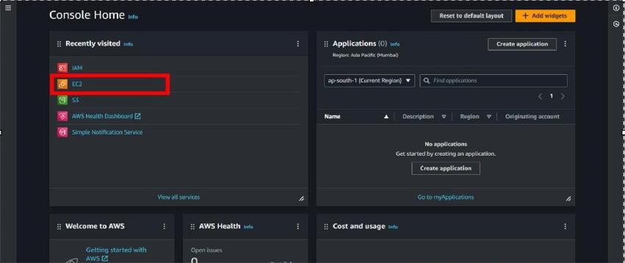

Create an EC2 Instance(ubuntu):

- For creating an EC2 instance follow the following steps as shown in

snapshots.
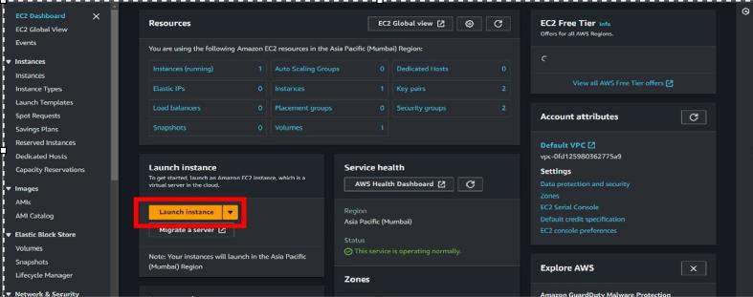

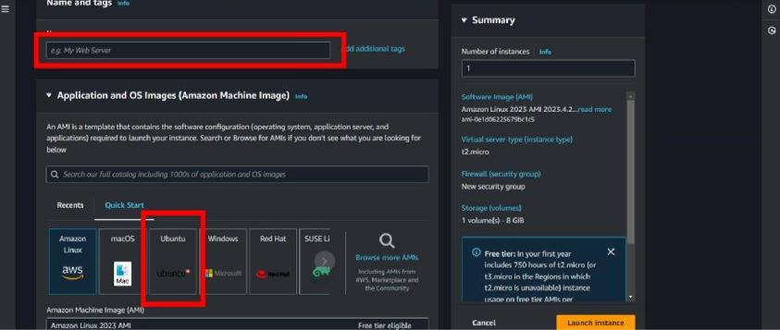

- Provide the EC2 name of your choise and select”Ubuntu”as an OS Image.
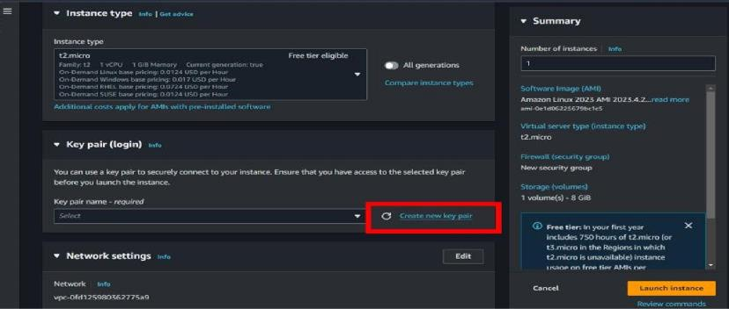

- Create a new key pair.
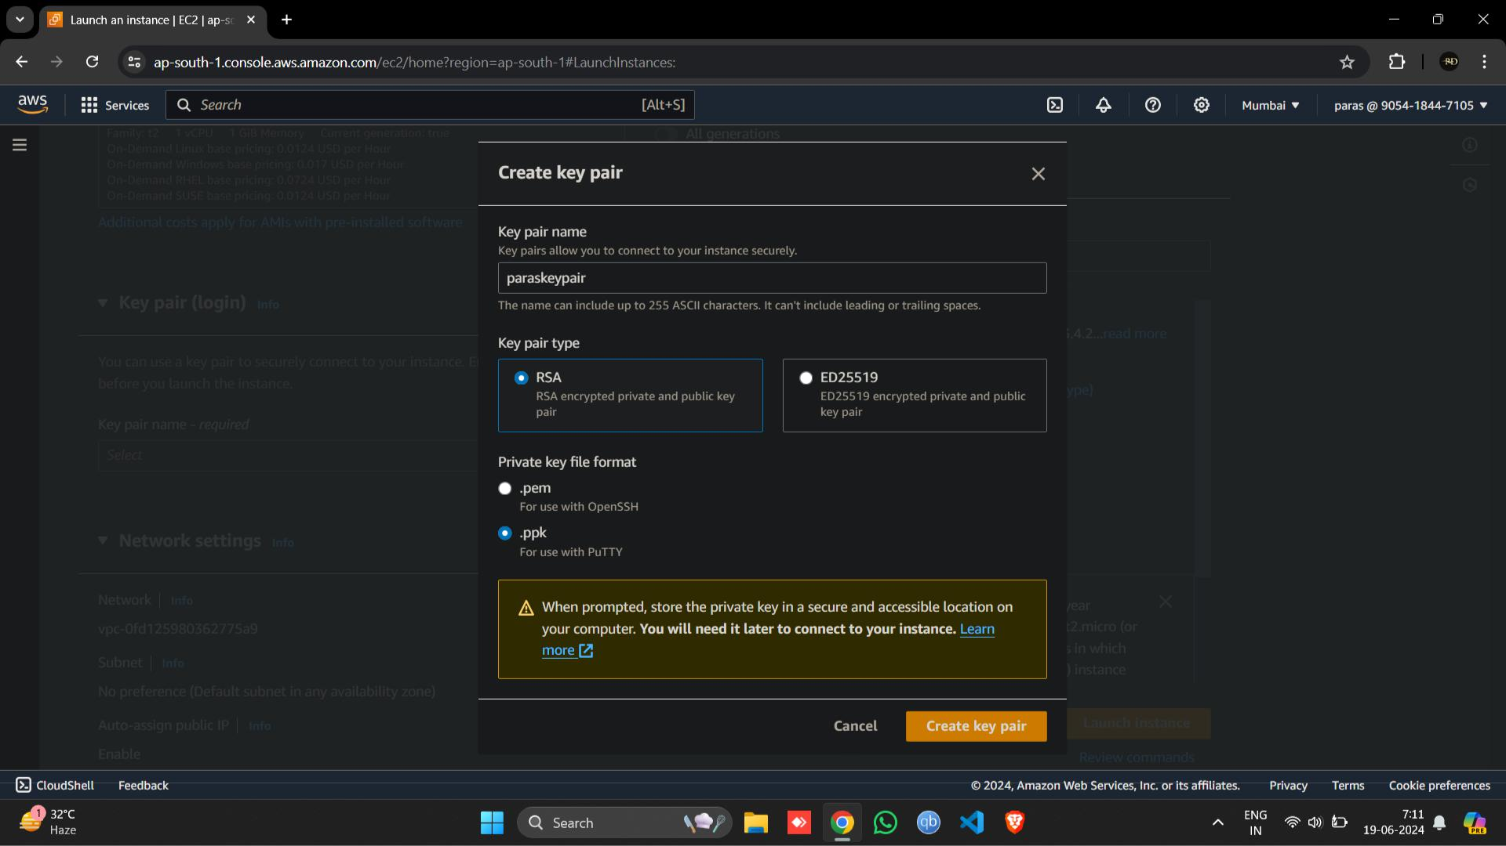
- Scroll down and click on “LAUNCH INSTANCE “.
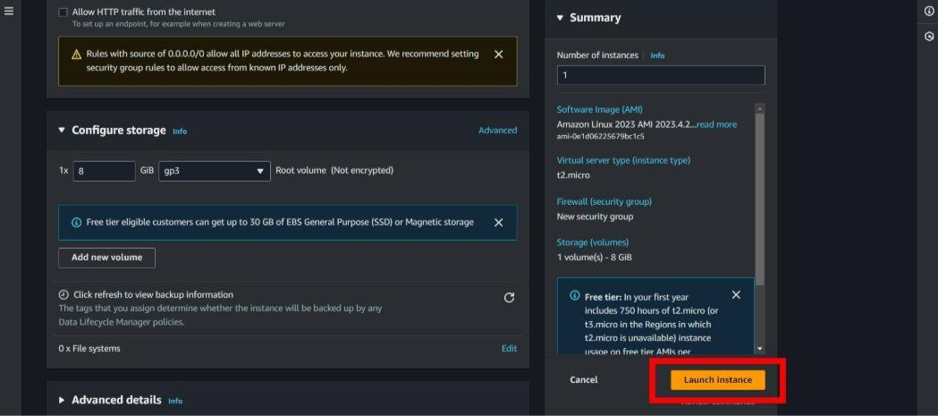

- Then open your instance and connect that instance by putty or on web browser.

- After connecting the instance follow the given command or read Grafana documentation for help.
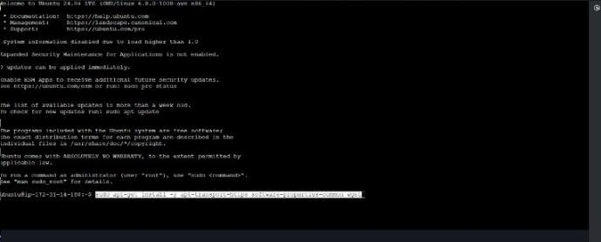

sudo apt-get install -y apt-transport-https software-properties-common wget

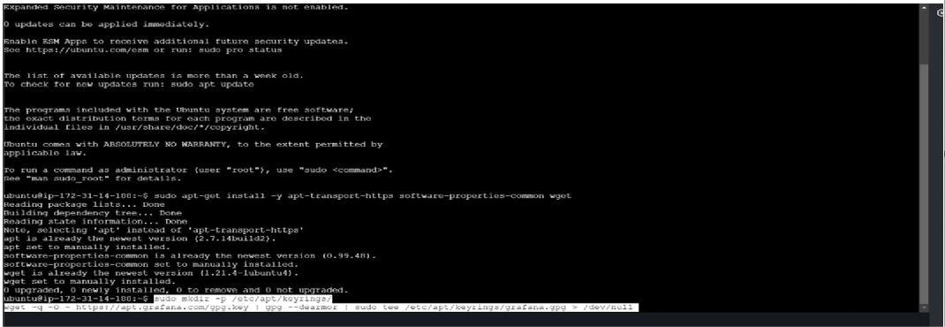

sudomkdir -p /etc/apt/keyrings/wget -q -O - https://apt.grafana.com/gpg.key |

gpg --dearmor | sudo tee /etc/apt/keyrings/grafana.gpg> /dev/null

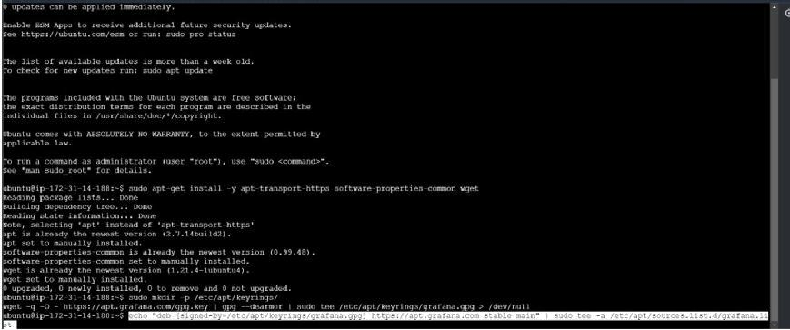

echo "deb [signed-by=/etc/apt/keyrings/grafana.gpg] https://apt.grafana.com

stable main" | sudo tee -a /etc/apt/sources.list.d/grafana.list

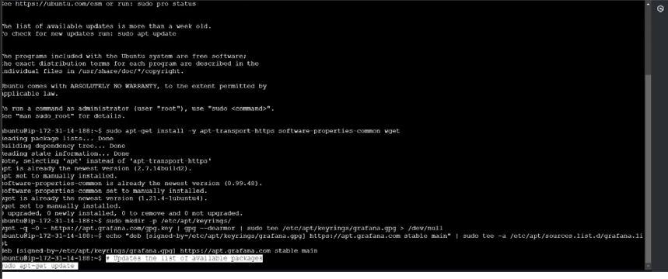

- To updates the list of available packages sudo apt-get update
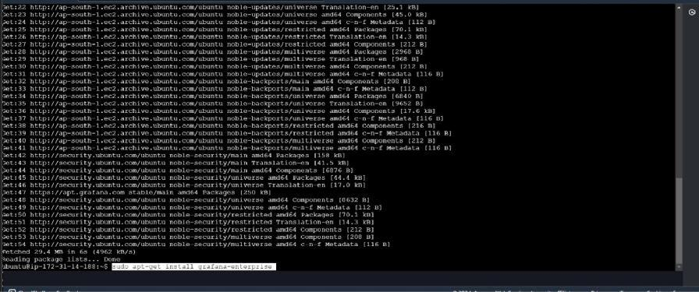

- To installs the latest Enterprise release: sudo apt-get install grafana-enterprise
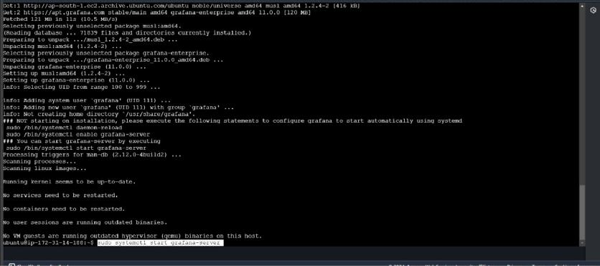

- sudosystemctl start grafana-server

- sudosystemctl enable grafana-server.service
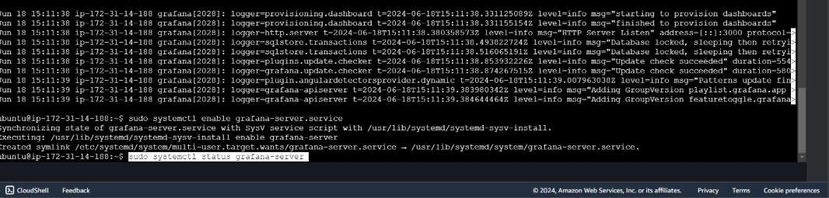

sudosystemctl status grafana-server.service
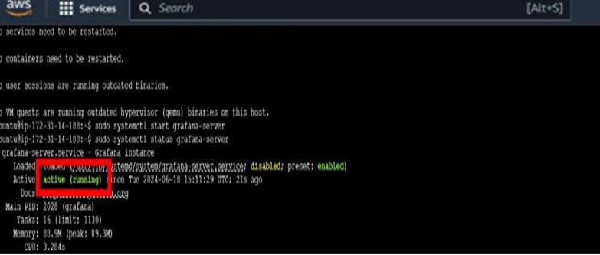
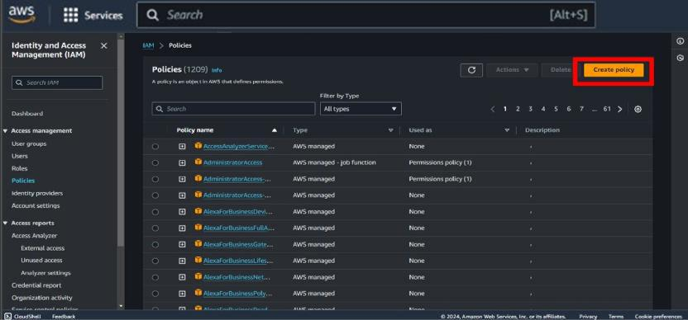

- Then search IAM role and go to policies and click on Create policies.
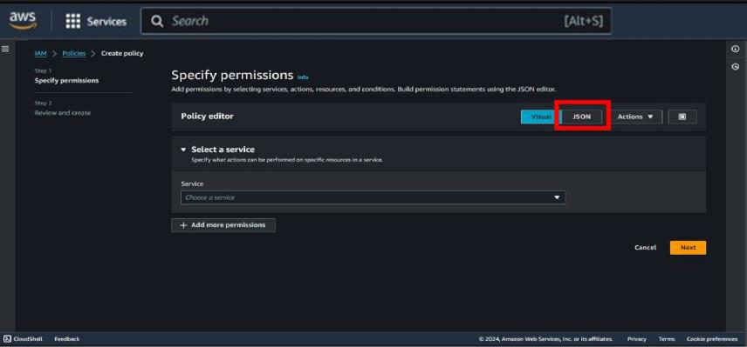

- Then go to JSON type.
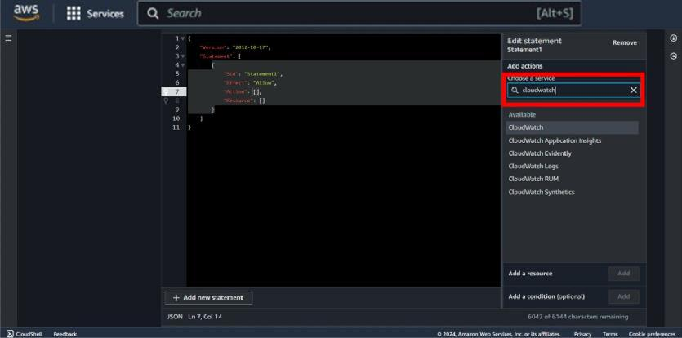

- Click on add action and search for “Cloudwatch”.
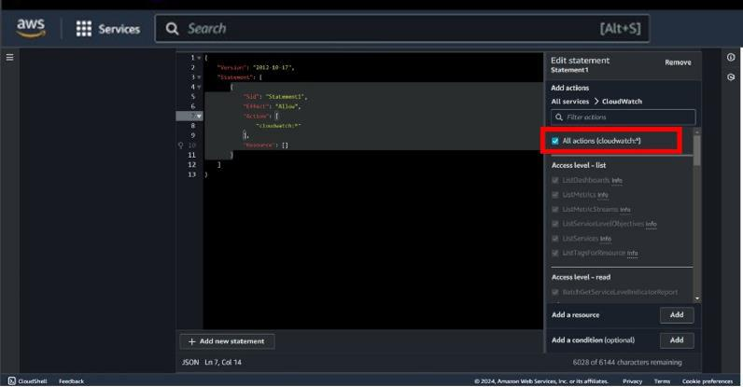

- After selecting cloudwatch select “All actions “.
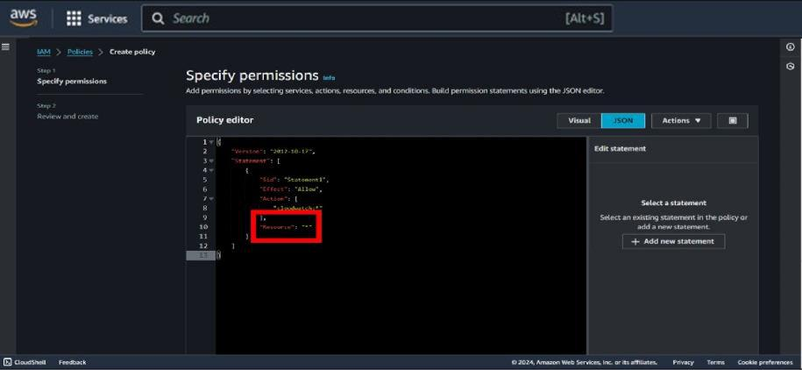

- Then put “Resource “ : ”*”
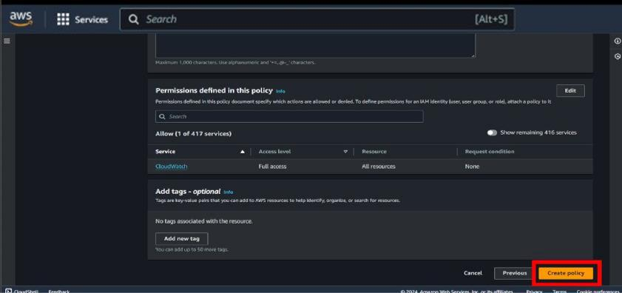

- Scroll down and click on Create policy.
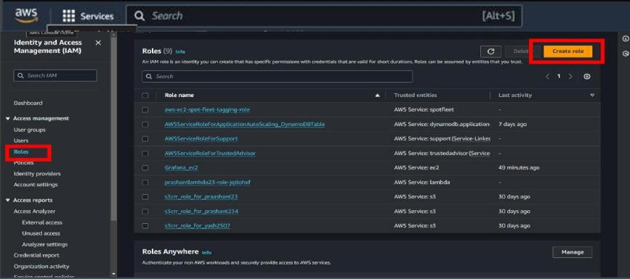

- Then go to roles and click on Create roles.
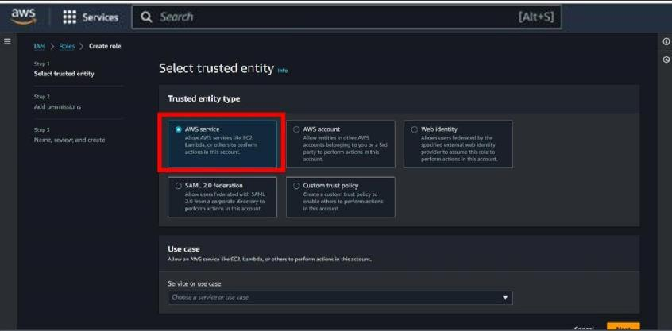

- Then select entity type is AWS services .
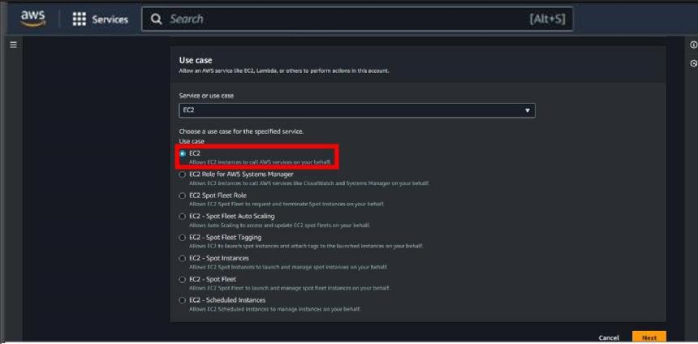

- Now , select use case as EC2 .

- Select your policy here which you have created previously , then click on

Next.

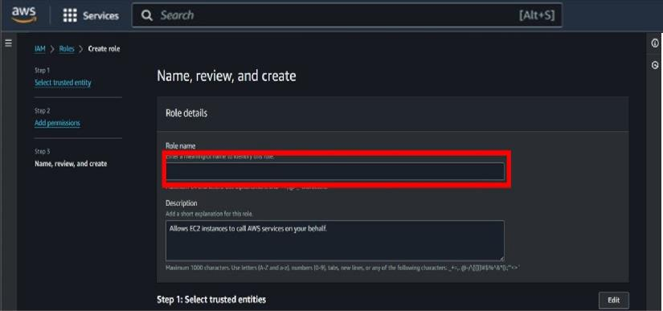

- Then give a name of your choise to the role .
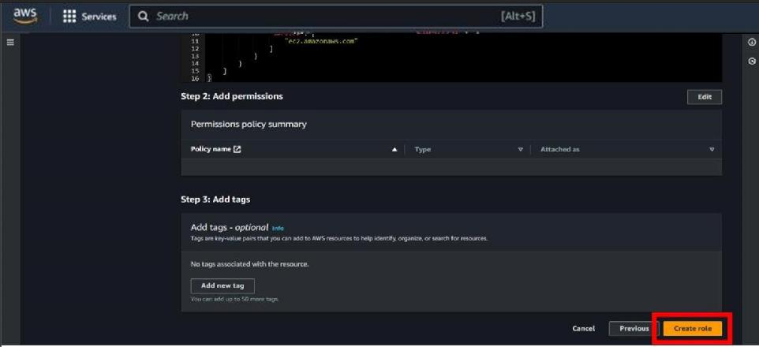

- Then scroll down and click on the Create role .

- After creating your role and policy go to instance and open your instance ,

which you have already created.

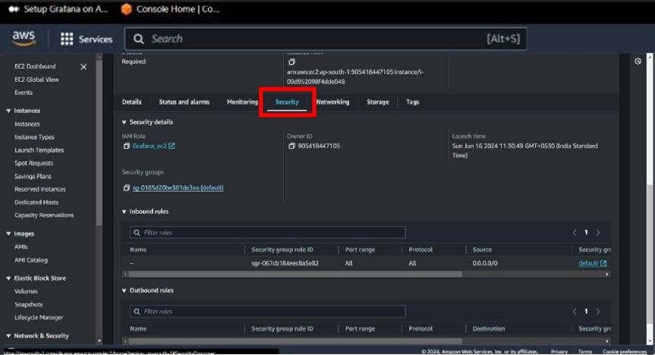

- Scroll down and go to Security option.
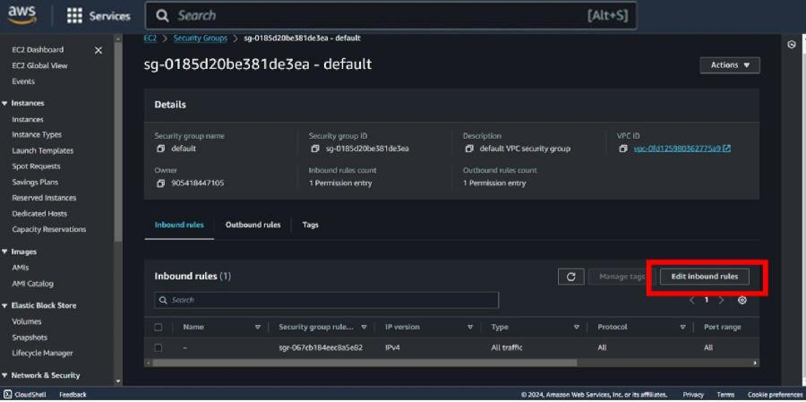

- Then click on Edit inbound rule .
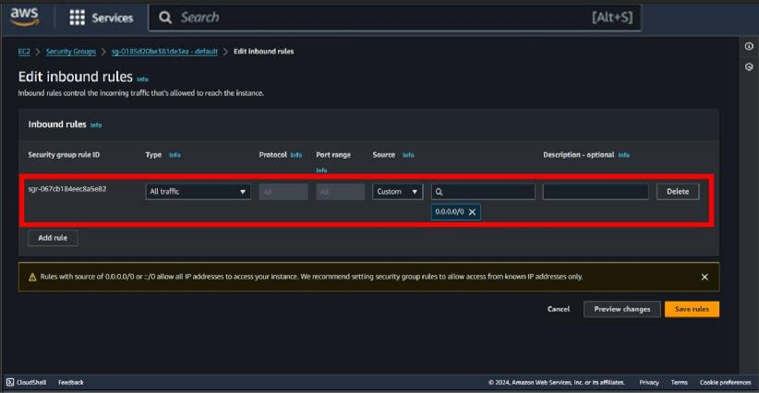

- Then modify your rule select type = All traffic and source =0.0.0.0/0
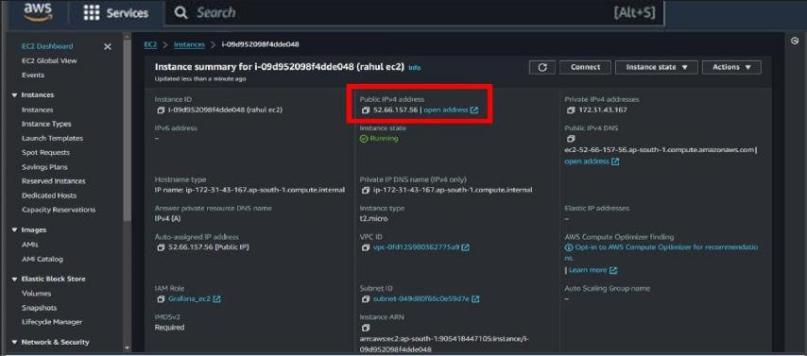

- Then copy your public IPv4 address of your instance .
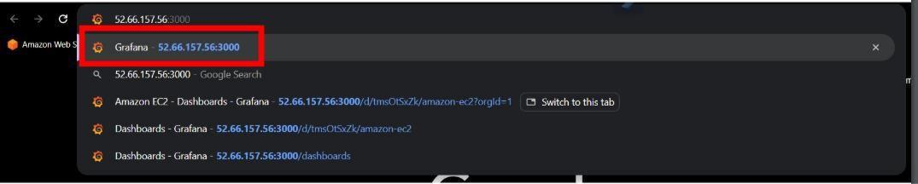

- Then paste your copied ip address and type “:3000” after ip address and

search it .

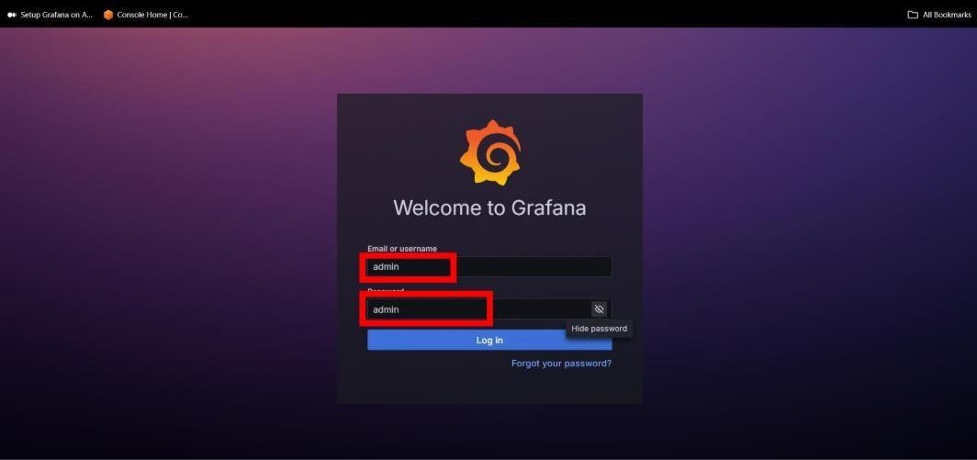

- Then login in Grafana by the help of credientials shown in above snapshot.
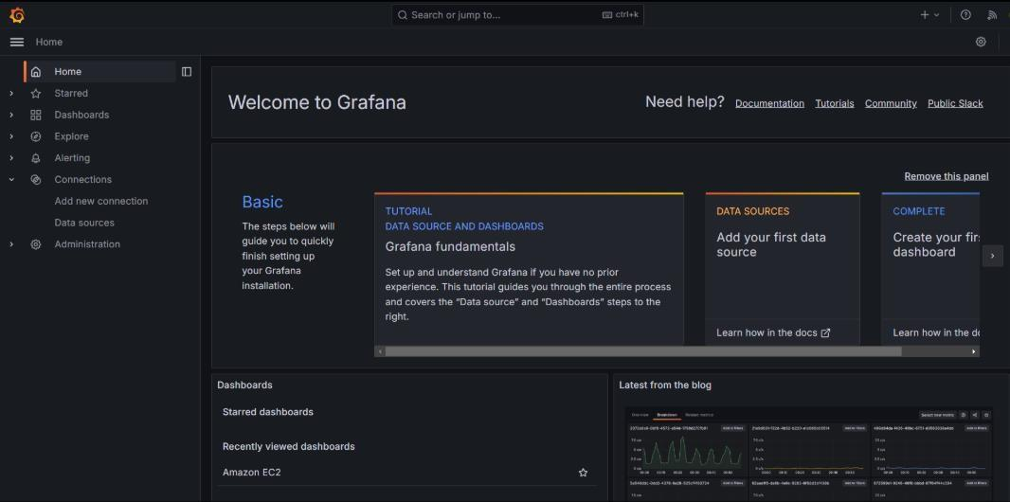
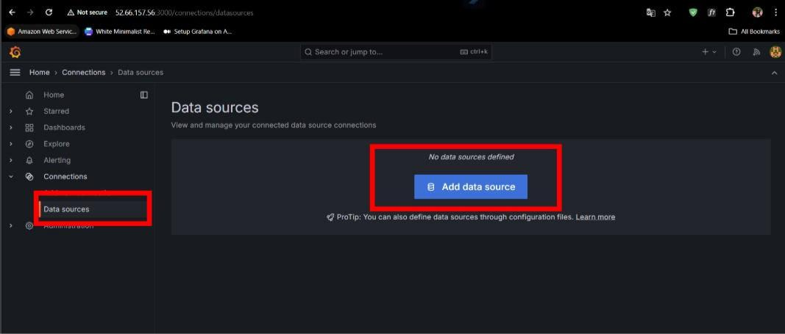

- Then go to Dashboard and click on Adddata source .
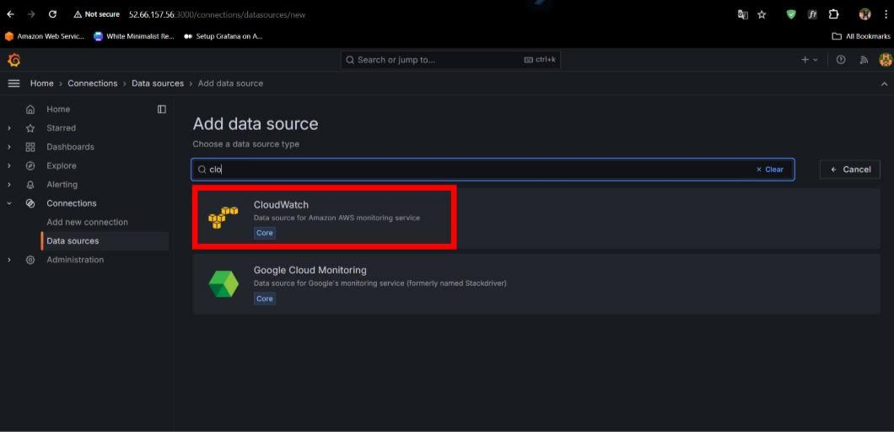

- Now , select “Cloudwatch” as an data source .
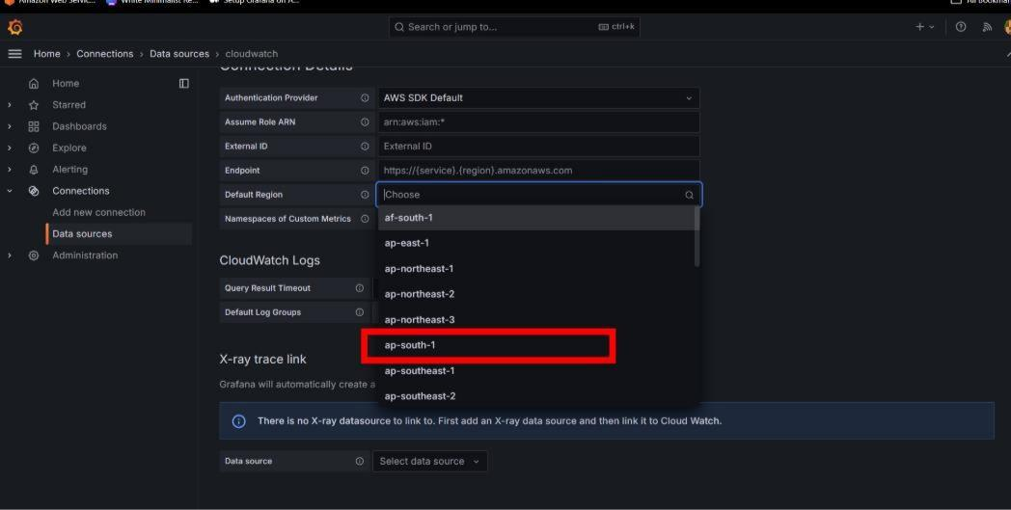

- Then after selecting cloudwatch select your region .
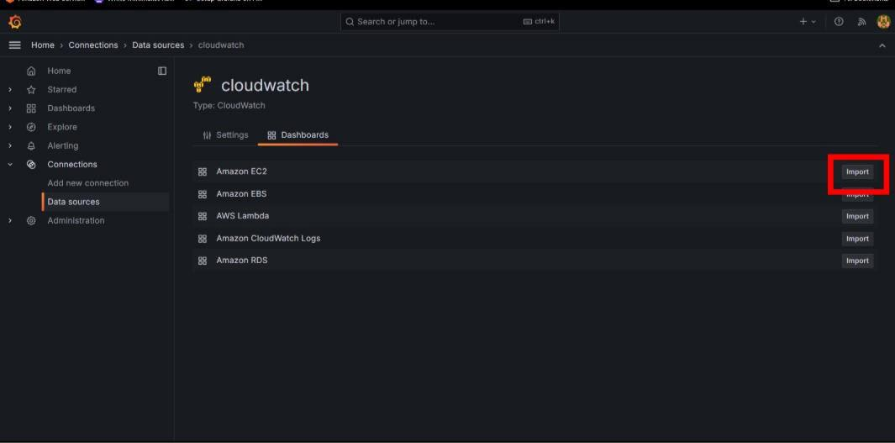
- Then inside your cloudwatch go to dashboard and Import EC2.
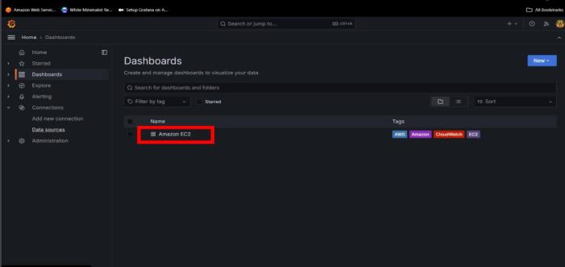

- Then go to dashboard and open your Amazon EC2.

